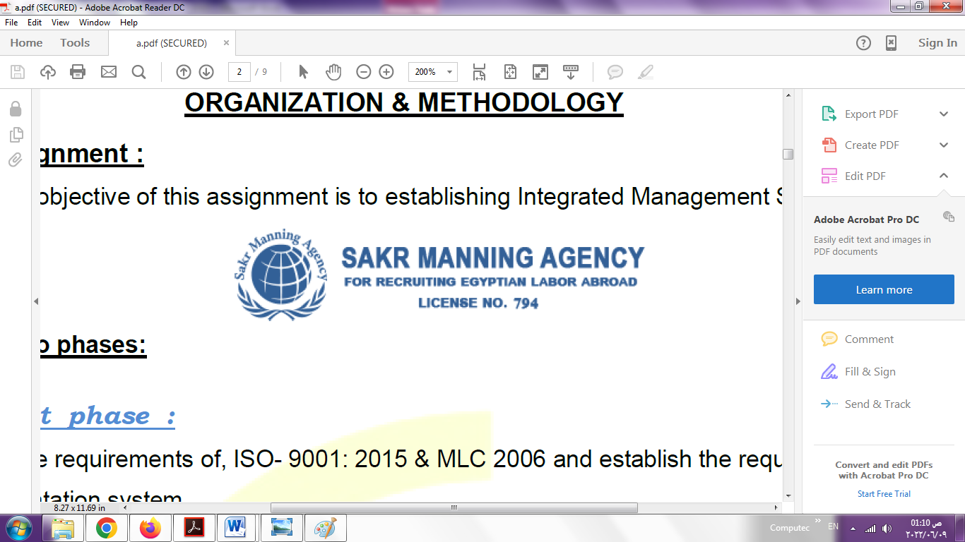 | SAKR MANNING AGENCY  FOR RECRUITING EGYPTIAN LABOR ABROAD | Issue Date | 15.05.2022
 |  | Revision Date | 19.07.2022
 | Crewing Management Manual  Seafarer Employment Application | Revision | 1.1
 |  | Page | 3

Application For Position as | WELDER / FITTER
Register Code. | ER-4.004
Other Position (If Any) | WELDER / FITTER
Register Date | 19.09.2022
Last up Date Data | 22.10.2024

1. PERSONAL DETAILS
Full Name |  | ESSAM SOBHY ABDELBAKY MAHMOUD SALEM
Date Of Birth |  | 25/02/1989 |  |  |  |  |  |  | Place Of Birth |  |  |  |  |  |  |  | EL BEHIRA
Nationality |  | EGYPTIAN |  |  |  |  |  |  | Marital Status |  |  |  |  |  |  |  | Single ☐ |  |  |  |  |  |  |  | Married ✔☐
Height (Cm) |  | 171 |  |  |  |  |  |  | Overall Size |  |  |  |  |  |  |  | XXL |  |  |  |  | Shirt Size |  |  |  |  |  | XXL
Weight (Kg) |  | 84 |  |  |  |  |  |  | Trouser Size |  |  |  |  |  |  |  | XXL |  |  |  |  | Shoes Size |  |  |  |  |  | 43
2. EDUCATION
College / School |  | DIPLOMA OF MECHANICAL AND INDUSTRIAL SCHOOL
Marline Test |  | Issued Date |  |  |  |  | Result % |  |  |  | Issued By (Authority) |  |  |  |  |  |  |  |  |  | Issued At
English Language |  | Fluent ☐ |  |  |  |  |  | Good ☐ |  |  |  |  | Average ✔☐ |  |  |  |  |  |  |  | Poor ☐
Arabic Language  ( ) |  | Fluent ☐ |  |  |  |  |  | Good ☐ |  |  |  |  | Average ☐ |  |  |  |  |  |  |  | Poor ☐
3. CONTACT DETAILS
Home Address / City |  |  | Kafr eldawar – Elbehira - Egypt
E-Mail |  |  | Essamsobhys89@gmail.com |  |  |  |  |  |  | Mobile / Tel |  |  |  |  |  | 01285520106 |  |  |  |  |  |  | 01228448687

4. TRAVEL DOCUMENTS
Type |  | Document No. |  |  |  | ISS. Date |  |  | Exp. Date |  |  |  |  | ISS. By (Authority) |  |  |  |  |  |  |  |  |  | Place of Issue
Passport |  | A29082212 |  |  |  | 24-10-2021 |  |  | 23-10-2028 |  |  |  |  | Egyptian Authority |  |  |  |  |  |  |  |  |  | KAFER ELDAWAR
Seaman Book |  | S00035113 |  |  |  | 27-09 -2023 |  |  | 24-09-2028 |  |  |  |  | EAMS |  |  |  |  |  |  |  |  |  | Alex.
Other Seaman Book

5. PROFESSIONAL QUALIFICATION / CERTIFICATE OF COMPETENCY
Certificate Name |  |  |  |  | Number | Issue Date |  |  |  |  |  | Expiry Date |  |  |  |  |  | Issued By |  |  |  |  |  |  |  |  | Issued At
COC |  |  |  |  | 00339 | 30-11-2020 |  |  |  |  |  | 11-03-2024 |  |  |  |  |  | EAMS |  |  |  |  |  |  |  |  | Alex.
GOC |  |  |  |  |  |  |  |  |  |  |  |  |  |  |  |  |  | NTRA |  |  |  |  |  |  |  |  | Cairo
D.P. INDUCTION
D.P. ADVANCED
D.P. OPERATOR (UNLIMITED)
6. NEXT OF KIN
Full Name | AYA SHEHATA RAMADAN ABDELGAWAD |  |  |  |  |  |  |  |  |  |  |  |  |  | Relationship |  |  |  |  | WIFE
Address | Kafr saleem – kafr eldawar – behira - egypt
Tel. No. |  |  |  |  |  |  |  |  |  | Mobile |  |  | 01285520106
7. HEALTH CERTIFICATES & VACCINATIONS
Flag State |  |  |  | Number |  |  | Issue Date |  |  |  |  | Expiry Date |  |  |  |  |  |  | Issued By |  |  |  |  |  |  | Issued At
International Medical |  |  |  | 20085 |  |  | 12-10-2023 |  |  |  |  | 11-10-2025 |  |  |  |  |  |  | EAMS |  |  |  |  |  |  | Alex.
Yellow Fever |  |  |  | 9455 |  |  | 02-01-2020 |  |  |  |  | forever |  |  |  |  |  |  | Ministry of Health
Cholera |  |  |  | 9455 |  |  | 21-01-2020 |  |  |  |  | 20-01-2023 |  |  |  |  |  |  | Ministry of Health
Covid-19 |  |  |  | Vaccination Name |  |  | First Dose |  |  |  |  | Second Dose |  |  |  |  |  |  | (Other Does or Remarks)
 |  |  |  | Moderna Biotech Spain S.L |  |  | 13-12-2021 |  |  |  |  | 12-01-2022

8. MARINE COURSES
Course Name | Number | Issue Date | Expiry Date | Issued By / At
Personal Survival Techniques | 43650/19/EG | 12-12-2019 | 11-12-2024 | Arabic academy for science, technology
Proficiency In Personal Survival Techniques
Fire Prevention and Fire Fighting | 43650/19/EG | 12-12-2019 | 11-12-2024 | Arabic academy
Advanced Fire Prevention and Fire Fighting
Elementary First Aid | 43650/19/EG | 12-12-2019 | 11-12-2024 | Arabic academy
Medical Care Studies
Personal Safety and Social Responsibilities | 43650/19/EG | 12-12-2019 | 11-12-2024 | Arabic academy
Proficiency Of Security Awareness Training Seafarers | 45725/19/EG | 31-12-2019 | 11-12-2024 | Arabic academy
Proficiency as a ship Security officer ( PSSO )
Proficiency In Survival Craft & Rescue Boats | NC 1527 | 19-01-2020 | 15-01-2025 | Naval post-graduate studies institute
Proficiency In Survival Craft & Rescue Boats | 05468 | 12-10-2023 | 15-01-2025 | EAMS / Alex.
G.M.D.S.S
Communications
Advanced Communications
ECDIS Advanced Simulator (Management Level)
ECDIS Simulator (Operation Level)
Prevention and Combating of Marine Pollution
Radar & ARPA Simulator and Search &rescue
ARPA Simulator and Search
Marine Radar and automatic Radar Plotting
Bridge resource Management (B.R.M)
Engine resource Management (E.R.M)
Navigational Watch keeping
Proficiency for Rating forming part of Navigational watch (II/4) |  |  |  | EAMS / Alex.
High voltage training – operation of ship (1000 Volt and More)
Passenger Safety Cargo Safety and Hull integrity | NXD956 | 20-02-2021 | 16-02-2026 | Naval post-graduate studies
Crowd Management Training | NXA948 | 20-02-2021 | 10-02-2026 | Naval post-graduate studies
Crisis Management and Human Behavior Training | NXB985 | 20-02-2021 | 13-02-2026 | Naval post-graduate studies
Safety training for Personal Prov. Direct Passengers | NXC971 | 20-02-2021 | 15-02-2026 | Naval post-graduate studies
Practical Ability to Prepare Meals and (MLC 2006)
Personal Hygiene and Envir. Protection (MLC 2006)
Safety and Health in the Provision Meals (MLC 2006)
Food Storage and inventory Control (MLC 2006)
Ships Cook Certificate (MLC 2006) |  |  |  | EAMS / Alex.
Abel Seafarer Deck
Proficiency for Abel Seafarer Deck ( II/5 ) |  |  |  | EAMS / Alex.
Engineering Watch keeping | NE 1061 | 11-11-2020 | 03-11-2025 | Naval post-graduate studies
Proficiency for Rating forming part of a watch in engine room | 00339 | 30-11-2020 | 11-03-2024 | EAMS / Alex.
Abel Seafarer Engine
Proficiency for Abel Seafarer Engine ( III/5 ) |  |  |  | EAMS / Alex.
Electro Technical Rating
Proficiency for Electro Technical rating ( III/7 ) |  |  |  | EAMS / Alex.

COMPLETE SEA – SERVICE DETAILS

Name: |  |  |  |  |  |  |  | Rank: |  |  |  |  |  |  |  | Register Code:
Company Name |  |  | Rank |  | Vessel Name |  |  |  | Signed On |  |  | Signed Off |  |  |  | Period |  |  | Vessel Type |  | D.W.T. |  |  |  |  | Engine Type |  |  | BH | KW
NATIONAL NAVIGATION CO |  |  | WELDER |  | WADI SUDR |  |  |  | 20-02-2020 |  |  | 05-10-2020 |  |  |  | 8 months |  |  | BULK |  | 70,000 M/T |  |  |  |  | MAN B&W 7S50MC |  |  | 11640 | 8555
NATIONAL NAVIGATION CO |  |  | WELDER |  | WADI ALBOSTAN |  |  |  | 21-04-2021 |  |  | 15-10-2021 |  |  |  | 6 months |  |  | BULK |  | 57320 M/T |  |  |  |  | MAN B&W 6S50MC |  |  | 12900 | 8058
UNITED MARINE EGYPT (UME) |  |  | WELDER |  | WASA EXPRESS |  |  |  | 20-10-2021 |  |  | 30-06-2022 |  |  |  | 8 months |  |  | RORO/ PASSENGER |  | 2501 M/T |  |  |  |  | FOUR STROKE TURBO CHARGED. DIESEL ENGING |  |  | 20200 | 15060
BSM |  |  | WELDER |  | W KITHIRA |  |  |  | 01-11-2022 |  |  | 30-06-2023 |  |  |  | 8 Months |  |  | CONTAINER |  | 93552 |  |  |  |  | Diesel |  |  | 89570 | 65880
BSM |  |  | WELDER |  | W KAMPALA |  |  |  | 14-01-2024 |  |  | 27-03-2024 |  |  |  | 3 Months |  |  | CONTAINER |  | 93617 |  |  |  |  | Diesel |  |  | 80654 | 65880
V.Ships |  |  | WELDER |  | ALEXANDROS PETRAKlS |  |  |  | 17-04-2024 |  |  | 08-07-2024 |  |  |  | 3 Months |  |  | BULK Carrier |  | 76596 |  |  |  |  | MAN B&W 6S60MC |  |  | 76596 | 10320
SPECIALISED EXPERIENCE
Name |  |  |  |  |  |  |  |  |  | Type |  |  |  | From |  |  | To |  |  |  |  | Comments
I declare that the information I have given is, to the best of my knowledge, true and complete. I also declare that the documents submitted are genuine, given and sign by persons whose names appear on them.
 |  |  |  |  |  |  |  |  |  |  |  |  |  |  | DATE |  |  |  |  |  |  |  |  |  | SIGNATURE

